Deep Space Navigation A stable space navigation based on X-ray and radio pulsar signals

Chen Jianheng 24097164g, Lin Yi 24127336g, Pan Zhiqing 24037665g,

Song Yanlin 24042403g, Zhang Xiaoxun 24070077g, Zhou Kaiwen 24045295g

**Content**

1. Introduction 3

1.1. Research Background 3

1.2. Domestic and International Research Status 4

1.2.1. International Research Status 4

1.2.2. Domestic Research Status 4

2. Navigation Requirements 5

2.1. Hardware and Instrumentation Requirements 6

2.1.1. X-ray Detector Requirements 6

2.2. Navigation Evaluation Requirements 6

2.2.1. Accuracy 6

2.2.2. Coverage 7

2.2.3. Continuity 7

2.2.4. Integrity 7

3. System Design and Principles 7

3.1. Principles 7

3.1.1. Very Long Baseline Interferometry (VLBI) 7

3.1.2. VLBI Observables and Data Processing 9

3.1.3. Pulsar and XNAV(X-ray Pulsar Navigation) 11

3.2. System Design 12

3.2.1. System Architecture 12

3.2.2. Build Pulse Star Database 13

3.2.3. XNAV System 14

4. Analysis on Performances of the Designed system 15

4.1. Navigation Accuracy within the Solar System 16

4.1.1. Positioning Accuracy 17

4.1.2. Timing Accuracy 17

4.1.3. Positioning Accuracy 17

4.1.4. Timing Accuracy 18

4.1.5. Positioning Accuracy 18

4.1.6. Timing Accuracy 18

5. Discussion and Conclusion 19

5.1. Discussion 19

5.1.1. Comparison with GNSS 19

5.2. Conclusion 20

Reference 22

1. Introduction
   1. Research Background

For the past few years, with the development of science and technology, the scope of human space exploration has been continuously expanding in depth, putting forward new requirements for the navigation and positioning of spacecraft. Traditional near-Earth orbit navigation technologies, such as the Global Positioning System (GPS), cannot be effectively applied in the deep space environment due to reasons such as the sharp attenuation of signal strength and limited coverage (Bernhardt et al. 2011). The deep space environment is different from the near-Earth surface environment. It has characteristics such as being extremely far away from the Earth, having huge signal propagation delays, and being complex and changeable in terms of spatial environment. Therefore, finding new stable and reliable sources of navigation signals has become a key issue in the field of deep space navigation. Among them, some compact objects can emit stable and characteristic X-ray signals, and radio pulsars can periodically emit extremely stable radio pulsar signals, providing a natural high-precision "space-time reference" for deep space navigation (Ray et al. 2008). These signals are relatively stable in the deep space environment and can travel long distances, which can provide precise navigation information for spacecraft in the deep space regions far from the Earth, helping to achieve deeper space exploration with more complex missions (Chen et al. 2020).

Compared with traditional navigation methods such as optical observation or rough orbital calculation, in the deep space context, optical observation is easily interfered by the complex cosmic environment, such as interstellar dust shielding, light scattering and absorption, etc., resulting in severely impaired observation accuracy; while rough orbital calculation, due to model simplification and data limitations, can only provide approximate position and velocity information with a large error range, which is difficult to meet the high requirements of deep space exploration for high-precision navigation. The navigation system based on X-ray signals and radio pulsar signals can provide more accurate position, velocity and time information, enabling spacecraft to reach target celestial bodies more accurately, conduct scientific exploration, sample return and other tasks, improving the success rate of missions and reducing risks (Franzese and Topputo 2020). The precision navigation capability enables the spacecraft to maintain the correct orbit and heading during long distance flights.This enabled the exploration of more distant objects, such as those in the Kuiper Belt and Oort. Clouds help us understand more fully how our solar system formed and evolved. The research on high-precision reception, processing and analysis technologies of X-ray and radio pulsar signals will promote the innovation and upgrading of space communication, space electronic equipment, spacecraft orbit control and other technologies, laying a solid technological foundation for more advanced future space missions. The high-precision processing requirements for X-ray and radio pulsar signals will force the performance of space electronic components to achieve a leap and innovation breakthrough (Xue et al. 2011). For example, in order to accurately capture and analyze these weak and complex signals, it is urgent to develop detectors with higher resolution, faster response speed and stronger anti-interference ability. Such advanced detectors will adopt new materials and processes, optimize the internal structure design and improve the signal sensing and conversion efficiency. At the same time, to deal with the high-speed processing and complex operations of massive signal data, it will also promote the development of more powerful, efficient and low-power signal processing chips. This research involves multiple disciplinary fields such as astronomy, physics, aerospace engineering and electronic information science. By conducting research on deep space navigation based on X-ray and radio pulsar signals, it can promote the cross-integration and collaborative innovation among different disciplines, promote the common progress of relevant disciplinary theories and technologies, generate new scientific discoveries and technological breakthroughs, such as in-depth research on the physical properties of pulsars and the development of new navigation algorithms.

* 1. Domestic and International Research Status
     1. International Research Status

The United States is in a leading position in the world in using X-ray and radio pulsar signals for deep space navigation (Liu et al. 2013). The National Aeronautics and Space Administration (NASA) has carried out a series of related research projects and experiments to promote the development of deep space research. Some deep space probes that have been launched are equipped with radio pulsar navigation test equipment to conduct practical verification of the application of pulsar signals in deep space navigation. In terms of X-ray navigation, it is also actively exploring technologies for spacecraft positioning and attitude determination using X-ray sources (Xue et al. 2015). Some research institutions and universities in the United States are also continuously conducting in-depth research on the characteristics of pulsar signals, optimization of navigation algorithms and integrated design of navigation systems, striving to build a practical deep space pulsar navigation system to provide comprehensive support for future deep space exploration goals.

The European Space Agency (ESA) has carried out various theoretical research and technology development work in radio pulsar navigation, including pulsar signal processing algorithms, navigation constellation design, etc. At the same time, some scientific research teams in European countries, based on X-ray astronomy research, are exploring the feasibility of applying X-ray sources to deep space navigation, collaborating with related enterprises to carry out some small experimental projects to verify the effectiveness of X-ray navigation technologies in specific deep space mission scenarios, and actively participating in international cooperation, sharing data and experiences with countries such as the United States in the research of deep space navigation technologies to jointly promote the development of this field.

* + 1. Domestic Research Status

In recent years, China has also made remarkable progress in the research of deep space navigation. In terms of radio pulsar navigation, multiple domestic universities and scientific research institutions have jointly carried out research and achieved a series of results in pulsar signal detection, processing technology and verification of navigation principles. A radio pulsar observation experimental platform has been established to conduct long-term monitoring and data collection of some known pulsars for studying the application characteristics of pulsar signals in navigation. In terms of algorithm research, various autonomous navigation algorithms based on pulsar signals have been developed, and their performance has been evaluated and optimized through computer simulation and ground semi-physical simulation experiments (Wang et al. 2015).

China is also gradually strengthening its research efforts in X-ray navigation. Some scientific research teams have achieved certain results in the observation and analysis of X-ray sources and the research and development of X-ray detector technologies, laying a foundation for subsequent research on deep space navigation based on X-ray signals. At the same time, China is also actively exploring the application of deep space navigation technologies in aerospace engineering practice. In lunar exploration and other missions, attempts have been made to introduce new navigation technologies to verify their feasibility, which can accumulate valuable experience for the construction of future deep space navigation systems. With the continuous development of China's aerospace industry, the investment in the research of deep space navigation technologies is also continuously increasing. It is expected that more breakthrough results will be achieved in this field in the future, enhancing China's autonomous navigation ability and international competitiveness in deep space exploration.

In conclusion, the research on deep space navigation based on stable space navigation X-ray and radio pulsar signals is in an active development stage both at home and abroad. It has broad application prospects and important scientific value, and can play a crucial role in future deep space exploration missions and promote the further leap of aerospace technologies.

1. Navigation Requirements

The spacecraft positioning system based on X-ray pulsars comprises primarily an X-ray detector, a spacecraft-borne atomic clock, a spacecraft-borne computer device, a navigation model algorithm database, and a pulsar model database. Fig. 2-1 depicts the workflow of the complete system.

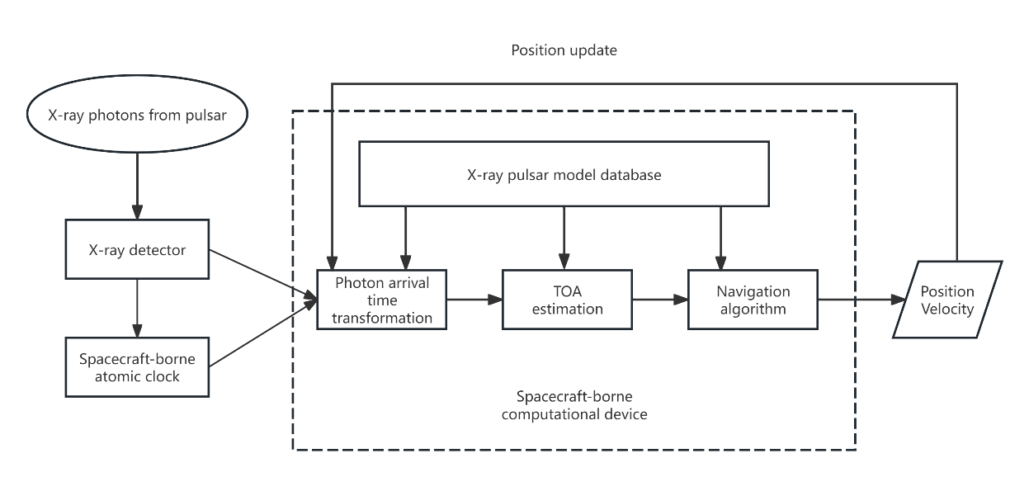

Fig. 2-1 Basic scheme of a spacecraft positioning system based on X-ray pulsars

The process begins when X-ray photons from pulsars reach the spacecraft's X-ray sensors. These X-ray pulsars function as natural clock beacons, similar to the GPS satellites on Earth. The X-ray detector installed on the spacecraft detects the pulsar's X-ray photons and uses a high-precision spacecraft-borne atomic clock to measure the time. Accurate measurement of each photon's arrival time is required for reliable navigation. The system then translates the photon's arrival time into data, making numerous modifications, including those required for spacecraft motion, before preparing it for comparison with the pulsar model. The system's second component is an X-ray pulsar model database, which contains detailed information about known pulsars such as pulse patterns, frequencies, and other characteristics. The converted arrival time is compared to this model database to calculate the pulsar signal's time of arrival (TOA), which is a key step in identifying the spacecraft's position. After estimating the TOA, navigation algorithms employ arrival time data from many pulsars to calculate the spacecraft's present position and speed. Finally, the spacecraft's navigation system is updated based on the calculated position and speed, allowing it to automatically determine its exact location in deep space.

* 1. Hardware and Instrumentation Requirements
     1. X-ray Detector Requirements

An X-ray sensor consists of two fundamental components: optics (for collecting radiation entering the sensor) and a detector. The photons' time of flight can then be determined. X-ray optics often employs focusing optics and collimators. X-rays are easily absorbed by most materials due to their refractive indices being near to one. X-rays can, however, execute efficient total external reflection from a highly polished border if they contact the surface at a modest grazing incidence angle. Because X-rays are focused on a limited region, focusing optics have the potential to offer greater resolution imaging and telescope sensitivity than collimators (Hui-Jun et al. 2012).

The pulsar signal is extremely weak, and the spacecraft can only capture a succession of photon TOAs, not a continuous pulse signal. Present study in pulsar signal processing concentrates on finding periods in recorded photon TOAs and extracting the pulse TOA.

First, the cycle search aims to determine the pulsar signal's period is crucial for retrieving the pulsar profile. The traditional Fourier transform cannot be used directly to calculate the period. Cycle search strategies for uneven sampling issues have a long history, including the Lomb-Scargle periodogram, the string length method, the autocorrelation method, phase dispersion minimization, variance analysis, and information theory approach.

When the spacecraft is believed to be stationary or moving uniformly, there are two types of pulse TOA computation methods: time-folded and direct use of photon TOA. Golshan et al. (Golshan and Sheikh 2007) devised a phase-tracking technique for orbiting spacecraft that estimates the pulse TOA and time-varying frequency. This method approximates the spacecraft's orbit as a piecewise constant model, ensuring that the frequency inside each segment may be accurately estimated as constant. The pulse TOA and frequency of all segments will be easily computed using a well-known approach. Finally, a digital phase-locked loop (DPLL) is utilized to monitor the frequency variations of each segment. To deal with the DPLL's noise, it can be converted into a two-dimensional Kalman filter. The phase-tracking approach is effective for youthful pulsars, however, it fails to detect weak pulsars. To test X-ray pulsar-based navigation positioning's applicability to dim pulsars, we changed the propagation model of the pulsar signal to include the spacecraft position and linearized the propagation model using the spacecraft's orbital dynamics information (Zheng and Wang 2020).

* 1. Navigation Evaluation Requirements
     1. Accuracy

According to recent study, X-ray pulsar-based navigation positioning accuracy has improved to within tens of kilometers. In 2018, Po-Ting Chen et al. revealed that after a day of pulsar data processing on the International Space Station, the X-ray pulsar-based navigation positioning accuracy was around 10 km. (Chen et al. 2020). In 2023, researchers used 16 days of pulsar data from the Fermi gamma-ray burst monitor to achieve an absolute navigation accuracy of 20 km. (Luo et al. 2023). China's satellite performed X-ray pulsar navigation in orbit, with location and speed precision of 10 kilometers and 10 meters, respectively, for five days(Zheng et al. 2019). These experiments demonstrate the possibility of X-ray pulsar-based navigation technology to provide accurate navigation for long-term space missions, particularly when traditional navigation technologies are ineffective.

* + 1. Coverage

Pulsars exist throughout the galaxy, and multiple pulsars can generally be seen from wherever the spacecraft is, allowing for continuous navigation. Unlike existing navigation systems, such as the Global Positioning System (GPS), which are restricted to near-Earth operations, X-ray pulsar-based navigation runs efficiently throughout the solar system and beyond, making it perfect for deep space missions when traditional systems fail. (Golshan and Sheikh 2007).

* + 1. Continuity

There are numerous factors that influence the continuity of pulsar navigation. The first requirements is that the pulsar signal is stable. Millisecond pulsars have superior rotational stability and timing accuracy, comparable to atomic clocks. (Shuai 2021). The second aspect is environmental: waves in the interstellar medium can cause the signal to disperse, affecting its continuity. However, unlike radio waves, X-ray emissions from pulsars are less vulnerable to these influences, which improves the X-ray pulsar-based navigation system's reliability. (Winternitz et al. 2022). The third aspect is redundancy. Using signals from a large number of pulsars can increase data redundancy, allowing for cross-validation and increasing navigation system continuity(Sheikh 2020).

* + 1. Integrity

Pulsar navigation integrity is the system's ability to generate accurate and reliable data for spacecraft navigation. X-ray pulsar-based navigation systems can be combined with other navigation systems, such as star trackers or inertial measurement units, to improve the overall integrity of the navigation system by cross-checking and alternate possibilities(Luo et al. 2023). Pulsar signals employ advanced algorithms such as Kalman filters to estimate the spacecraft's position, concealing mistakes that can be found and fixed in the signal data to guarantee that the computed position falls within an acceptable accuracy range. Furthermore, the X-ray pulsar-based navigation system includes a fail-safe feature that will sound an alarm or switch to a backup system if the integrity threshold is reached. This ensures that the spacecraft does not rely on incorrect data during vital operations.

1. System Design and Principles
   1. Principles
      1. Very Long Baseline Interferometry (VLBI)

In the case that the study use a telescope with an aperture of D to observe electromagnetic waves with a wavelength of λ, the angular resolution of the telescope can be estimated by the following formula:

This study find that the angular resolution of the telescope is inversely proportional to the wavelength and directly proportional to the aperture, that is, when the wavelength of the electromagnetic wave being observed remains unchanged, the larger the aperture of the instrument, the smaller the angular resolution, and the higher the resolution. This also explains why radio telescopes used to observe radio waves have apertures ranging from tens of meters to hundreds of meters. At the same time, if this study chooses shorter wavelengths of electromagnetic waves as the observation objects, such as X-rays, gamma rays, etc., this study can use relatively small telescope apertures to achieve higher angular resolution, which is also the reason for using X-rays to observe pulsars. However, X-rays undergo severe attenuation when propagating in the atmosphere, and it can even be considered that the atmosphere is opaque to X-rays emitted from space, so this paper can only observe X-ray radiation outside the atmosphere, which is also the reason why space astronomical satellites are used in X-ray astronomy.

Interferometric measurement technology is a technique for determining the position of a source by measuring the phase difference between two or more sources. If this paper uses two radio telescopes that are far apart to observe the same celestial body and use interferometric measurement technology to measure the phase difference of the electromagnetic waves received by the two radio telescopes, then this study can measure the position of the celestial body or perform imaging through this method (Jennison 1958). Theoretically, as long as the two radio telescopes are far enough apart, this article can obtain a “virtual” telescope with excellent angular resolution. The conventional method is to use a cable to link the two telescopes for time synchronization, but the transmission process of the long cable often brings great errors, resulting in the accuracy of interferometric measurement decreasing with the increase of the baseline length.

To solve this problem, VLBI technology came into being. VLBI technology uses atomic clocks (generally hydrogen maser) to generate timestamps and records the observation values together with the timestamps on the storage medium, and then performs data post-processing centrally. Since two atomic clocks can ensure strict time synchronization, there is no need to use cables for time synchronization.

However, this approach has at least two bottlenecks: first, the diameter of the Earth is limited, even if the study set up telescopes at the North and South Poles respectively, the baseline length will not exceed the diameter of the Earth, and the theoretical highest resolution the study can obtain is also limited; second, this approach lacks real-time performance, the study need to wait until all data are collected before data processing can be carried out, which is unacceptable for some astronomical phenomena that require real-time observation. For the first point, some countries have proposed deploying telescopes in space and forming a VLBI observation network with ground-based radio telescopes. For the second point, real-time data processing can be achieved by leveraging modern communication infrastructure and cloud computing technology.

In 2019, people used the Event Horizon Telescope (EHT) (Collaboration 2019) to imagine a black hole, which is a successful application of VLBI technology. EHT is a VLBI synchronous observation network composed of multiple radio telescope baselines around the world, and its equivalent aperture is almost equal to the diameter of the Earth.

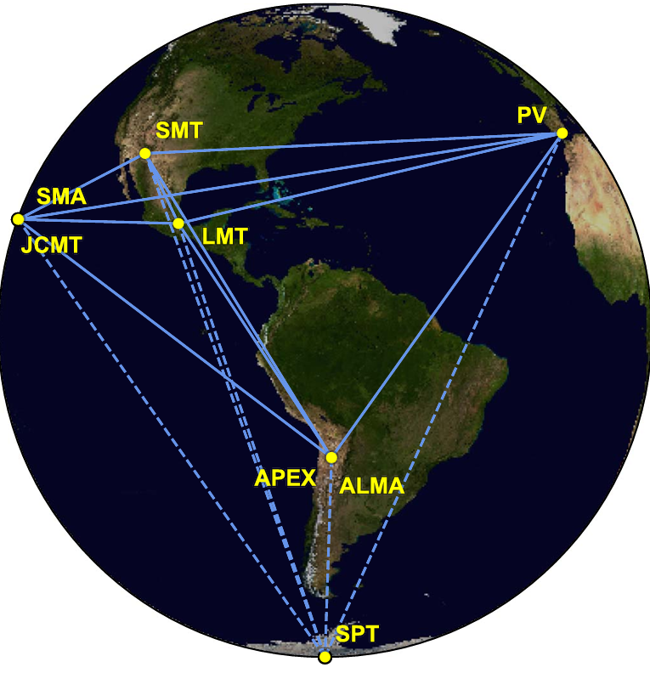

Fig. 3-1 The Event Horizon Telescope.

In summary, Very Long Baseline Interferometry can observe celestial bodies in space with extremely high resolution, providing unprecedented rich information for human beings. This study can fully obtain the most accurate cosmic information database under the current technical conditions based on VLBI technology and the ultra-high-resolution cosmic observation system developed on this basis. This database records the morphology, spectrum, motion laws, and positions relative to the barycenter of the solar system (SSB) of celestial bodies in space. In the following content, this study assumes that this database has been loaded onto the target, and the target can read and update the database at any time.

* + 1. VLBI Observables and Data Processing

Very Long Baseline Interferometry (VLBI) is essentially the measurement of the time difference (DTOA) and its rate of change of the electromagnetic waves radiated by the source reaching the two ends of the baseline at the same time. By observing multiple sources, the spatial coordinates of the baseline vector can be calculated and the position of the source can be determined (relative to the solar system barycenter (SSB)). Assuming that the time difference between the wavefront reaching the two ends of the baseline is τ_g, the study has:

Where c is the speed of light, |b| is the baseline length, θ is the angle between the baseline and the direction of the source. Since the source is quite far away, we regard the wavefront as a plane wave. In addition, since the initial state of the signal source is unknown, there will be ambiguity N, the study has:

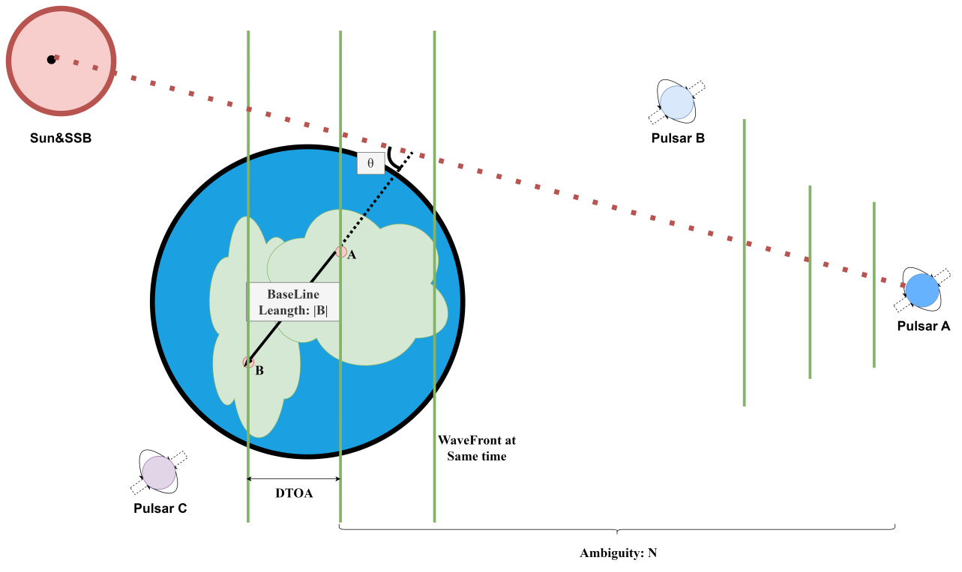

Fig. 3-2 Gromatry of VLBI.

In actual observations, due to equipment limitations, we cannot directly observe τ_g, we can only estimate τ_g through some signal and data processing methods, such as least squares method (Ghaderpour 2020), Fourier transform(Jennison 1958), etc.

The study can linearize the observation equation for least squares estimation or Kalman filtering and other data processing methods. The basic observation equation of VLBI can be expressed as:

Where O_t is the observation value including DTOA and its rate of change, C(X,t) is the model predicted value, and V_t is the observation error. Linearizing it.

If the weight coefficient matrix is P, then the least squares estimate is:

Where A is the partial derivative matrix, Y is the observation value, and P is the weight coefficient matrix.

If the paper considers the high precision of VLBI observation, we need to consider the errors brought by the relativistic effects (such as the errors brought by the lunar, Earth, and Jupiter gravity) since the DTOA observation accuracy of VLBI is about one-thousandth of the hydrogen maser timing accuracy, that is, about 10^(-11) seconds, and the relativistic effect mainly acts on the speed of light, that is, about 10^(-8) seconds. At the same time, for such high-precision observation activities, study also need to consider the errors brought by local factors such as the atmosphere, tides, solid tides, and Earth rotation of the astronomical telescope observation station, which are similar to the errors that need to be dealt with in GPS high-precision positioning.

Based on the above principles, we can establish a VLBI observation network on Earth. By observing multiple sources, we can calculate the spatial coordinates of the baseline vector and determine the position of the source (relative to the solar system barycenter (SSB)). We can store these observation data in a database for subsequent data processing and analysis, for example, we can load it onto a spacecraft for positioning and navigation in space (Nothnagel et al. 2017).

* + 1. Pulsar and XNAV(X-ray Pulsar Navigation)

Pulsars were first discovered in 1967 by Jocelyn Bell Burnell, when she detected signals received by a radio telescope. Pulsars are extremely dense, highly magnetized, and rapidly rotating celestial bodies, usually neutron stars or white dwarfs. Due to their high magnetization, they emit high-energy electromagnetic waves from specific directions, and due to their rapid rotation, these electromagnetic waves are detected by distant observers in the form of pulses. There are currently two main ways to detect pulsars, one is to continuously observe the microwave signals of pulsars using large ground-based radio telescopes with diameters ranging from tens of meters to hundreds of meters. The other is the telescope that receives X-ray signals. Since the wavelength of X-rays is much smaller than that of microwaves, we can use telescopes installed on small spacecraft to observe pulsars, such as the XPNAV-1 Mission (Zhang et al. 2017).

Pulsars have extremely short pulse periods, usually in the range of milliseconds to seconds, and are extremely stable. Some pulsars have pulse periods even more accurate than atomic clocks (Matsakis et al. 1997). Pulsars have become an ideal choice for astronomical navigation due to their stable pulse periods and high angular resolution, and are also candidates for ultra-high-energy cosmic ray sources. Each pulsar has its unique signal model(Ray et al. 2017), which can be used to identify different pulsars. The signal frequency of pulsars is not always stable and there will be some random changes, especially for young pulsars. Therefore, the pulsar navigation system needs to include at least two parts, one is the signal monitoring system with outlier detection, and the other is the pulsar database.

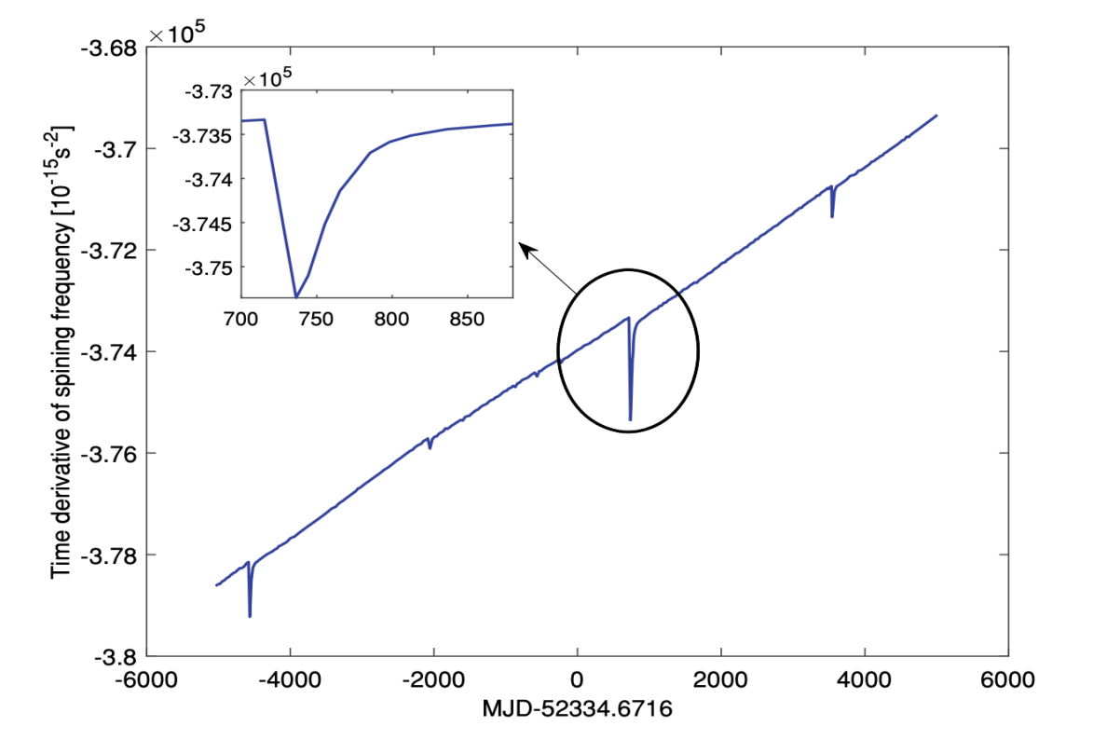

Fig. 3-3 an Example of Unstable Pulsar Signal.

Now, for space navigation based on X-ray pulsars, only one day of observation data (from a small airborne X-ray detector) is needed to obtain the three-dimensional position of a spacecraft with an accuracy of about 150 kilometers (Chester and Butman 1981). Traditional cosmic navigation technologies based on Earth’s deep space observation network (such as determining coordinates through angle measurement) will decrease in accuracy as the distance between the spacecraft and the Earth increases, while navigation using X-ray pulsars does not depend on the distance between the spacecraft and the Earth, and the accuracy will not decrease. For deep space navigation beyond 5 astronomical units from the Earth, the accuracy advantage of using X-ray pulsar navigation technology will be evident. This navigation system, which combines X-ray pulsar observation data with the spacecraft’s inertial navigation system (INS), is called XNAV. The main advantage of XNAV technology is its cost-effectiveness, which achieves high positioning accuracy and autonomy at a lower cost. With the development of compact X-ray antennas, XNAV technology has been widely used in deep space exploration tasks and can be carried on various types of aircraft, with its promotion significance comparable to GPS. In addition, the positioning accuracy of XNAV technology is also very good. For example, when using the pulsar PSR B1937+21, the spacecraft can achieve an accuracy of about 2 kilometers after 10 hours of observation within a range of up to 30 astronomical units; and after 1 hour of observation, the accuracy can reach 5 kilometers. (Shemar et al. 2016).

* 1. System Design
     1. System Architecture

Our system consists of three parts: VLBI observation network, pulsar database, and XNAV system. The VLBI observation network is responsible for continuously searching and observing pulsars, while the pulsar database processes the observation data and establishes and stores pulsar signal models. For the VLBI observation network, it can use the existing observation network on Earth or the observation network deployed in space in the future. The XNAV system is similar to a GPS receiver, installed on the target spacecraft that needs navigation, and is responsible for real-time positioning. If humans can launch large spacecraft (or detectors), it will be possible to deploy an observation network with ultra-long baselines in space. Assuming that we have multiple spacecraft heading in different directions, we can build a VLBI observation network with continuously increasing baselines through these spacecraft, thereby continuously improving the observation accuracy.

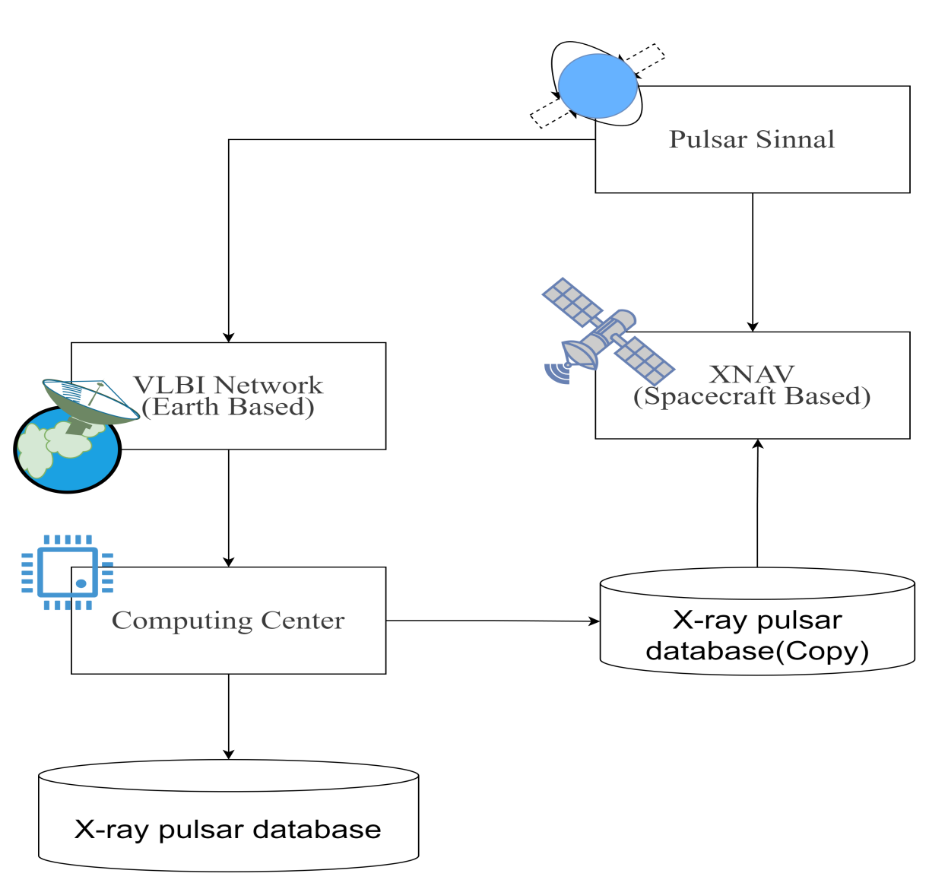

Fig. 3-4 System Architecture.

* + 1. Build Pulse Star Database

The prerequisite for achieving low-cost pulsar navigation (Ely et al. 2022) is to establish a complete pulsar database (especially X-ray pulsars). We need to search for those “high-quality” pulsar sources (pulsars with stable periods, pulse signals received, and good Geometry distribution), then observe them for a long time, establish pulsar signal models (clock models), and measure their positions relative to the SSB (including azimuth and approximate distance).

The establishment of the pulsar signal model is usually to observe and record the arrival time of the pulse signal (TOA). It should be noted that the pulsar clock model is also reduced to the solar system barycenter. We have the following formula to complete this conversion:

Where t is the calculated pulse arrival time observed at the solar system barycenter, T is the pulse arrival time observed at the ground station, Δt_1,Δt_2,Δt_3 are all clock correction numbers. V_i represents the remaining small correction terms, such as dispersion caused by interstellar medium, Shapiro delay, etc.

Based on the above observation values, the signal model of the pulsar (clock model) can be established. However, to solve the various parameters of the model, a very long observation (2-3 years) is required to collect enough observation records. Considering the instability of some pulsar signals, it is also necessary to update them from time to time to ensure the timeliness of the model. The following formula represents the pulsar signal model:

Where Φ(t) is the pulsar signal model, f(t) is the frequency of the pulsar signal, t_0 is the reference time, and m is the model order.

Considering that each pulsar signal model is unique, we can identify different pulsars based on the signal model of the pulsar. In addition, considering that the pulsar navigation system is ultimately aimed at human users, we can generate corresponding pulse contour maps based on the signal model of the pulsar for users to quickly identify the observed pulsars.

* + 1. XNAV System

The XNAV system is a navigation system based on pulsar signals (Dong 2008), the core of which is a small X-ray telescope used to observe pulsar signals. The workflow of the XNAV system is as follows:

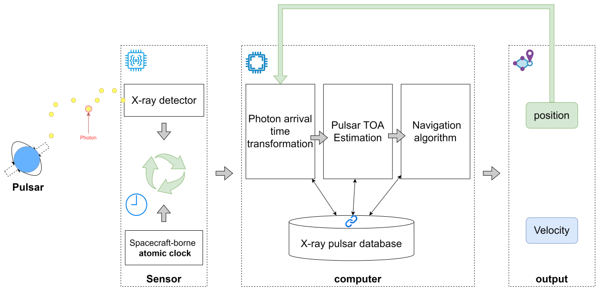

Fig. 3-5 Workflow of XNAV System.

Since the pulsar signal is not that strong, the spacecraft usually relies on atomic clocks to record the arrival time of photons (TOAs) and cannot record continuous pulse signals. Therefore, it is necessary to process the photon TOAs first to estimate the pulse arrival time (Pulse TOA). There are two methods to estimate the pulse arrival time: epoch folding method and direct use of photon TOAs method. The former estimates the pulse TOA by calculating the initial phase and period, and the latter obtains the result by maximizing the log-likelihood function. In this process, it is necessary to further refer to the signal model in the pulsar database.

The basic principle of X-ray pulsar navigation is to determine the position of the spacecraft by comparing the arrival time (TOA) of the pulsar signal received by the spacecraft with the predicted arrival time of the same signal received by the solar system barycenter (SSB). By measuring the difference between the measured and predicted pulse arrival times, the distance of the spacecraft relative to the SSB can be obtained. When observing three or more pulsars, the spacecraft can be geometrically positioned using a nonlinear least squares algorithm. The core mathematical model is as follows:

It can be found that the observation value here is the phase of the pulsar signal received locally. By comparing this phase with the phase predicted by the model at the solar system barycenter, the distance of the spacecraft relative to the solar system barycenter can be obtained. Similar to the GPS observation principle, the XNAV system can obtain multiple observation equations by simultaneously observing multiple pulsar signals, and then solve the position of the spacecraft using the nonlinear least squares method. Although the period of the pulsar signal may introduce integer ambiguity, this effect can be ignored when the initial navigation solution of the spacecraft has an accuracy of more than 300 kilometers. In each calculation period, the system needs to continuously update its position vector in addition to observing the pulsar signal (Yidi et al. 2023).

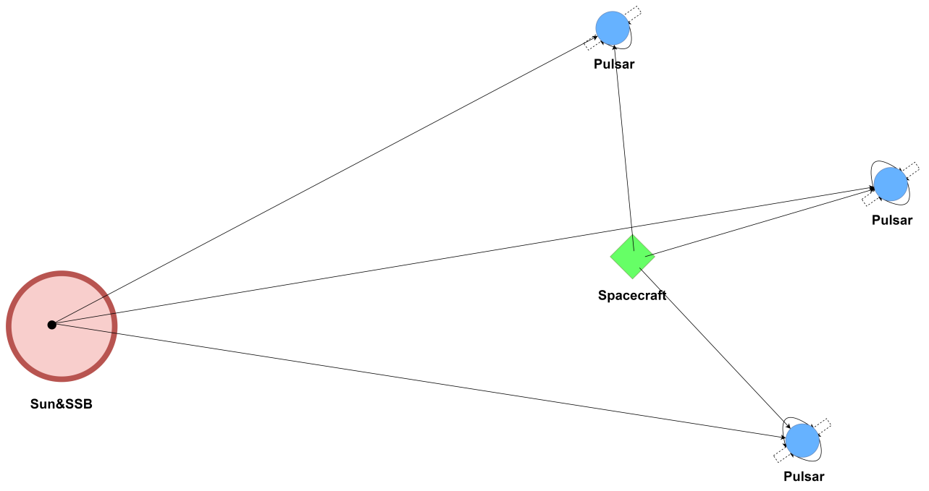

Figure 6: Pulse Star Navigation Principle

Multiple spacecraft simultaneously observe the same pulsar, and by comparing the pulsar arrival times (TOAs) received by them, the relative projection distance can be calculated, and the observation vector of the constellation can be constructed to improve the overall positioning accuracy of the constellation and support collaborative navigation. The integration of various data sources such as ground measurements, constellation observations, and star data can further improve the positioning accuracy. This means that we can build a deep space collaborative navigation network based on XNAV.

1. Analysis on Performances of the Designed system

Now let's discuss the performance analysis of this navigation system. First let's talk about the robustness of this system.

Robustness can often be used to reflect the ability of a system to maintain its functional stability in the face of changes in internal structure or external environment. It mainly consists of the following three features:

Fault tolerance: Fault tolerance is the ability of this system to maintain normal operation in the event of an error or failure. High fault tolerance means that the system maintains continuity of function and service even if some components fail.

Reliability: Reliability refers to the ability of the system to maintain normal operation under the intended use environment and the probability that no errors will occur in a certain period of time, reflecting the adaptability of the system to long-term continuous use.

Flexibility and adaptability: Flexibility refers to the ability of a system to adapt to changes, such as technological upgrades or changes in the environment. Adaptability refers to the ability of the system to respond to these changes, allowing the system itself to change quickly to maintain efficiency.

In the deep space region of the universe, satellite navigation systems often face the problem of weak signal and signal interference. The system uses signals from radio pulsars and is highly stable, making it ideal for long-duration deep space missions. So the system can work stably even when it is far from Earth or conventional satellite networks.

Now let's discuss the core metrics for judging the performance of the system, as shown in the following table.

Table 4-1 the Performance of the System

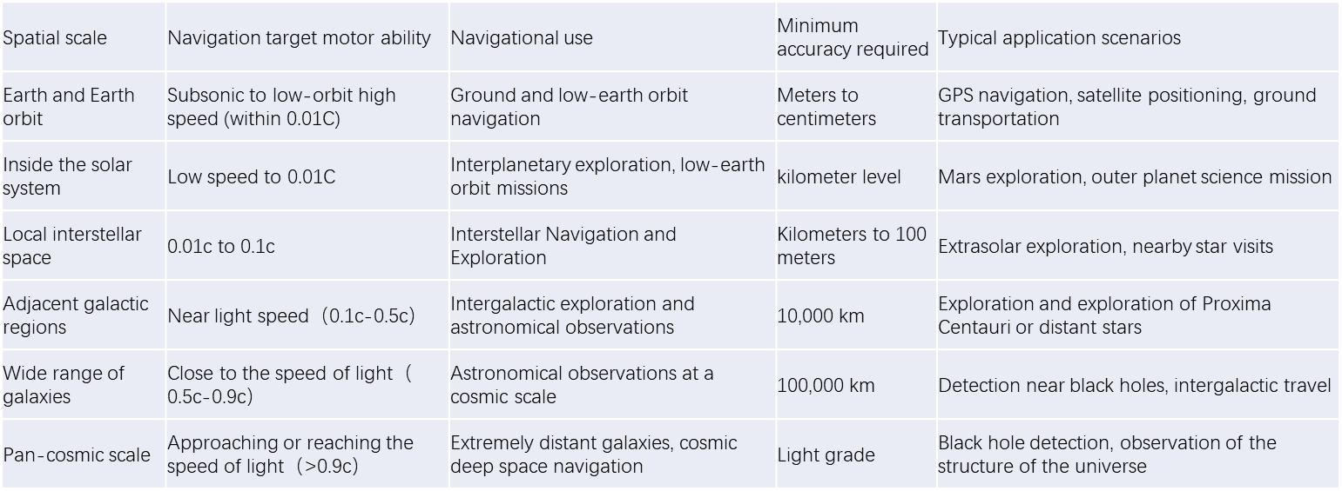

As can be seen from this table, we have different requirements and divisions for the performance of this system at different spatial scales. From small to large, space scales are divided into Earth and Earth orbit, inner solar system, local interstellar space, neighboring galactic regions, broad galactic ranges, and pan-cosmic scales. The navigation system has great difference in the motion ability of the target to be navigated under these scales, so it is refined to 6 scales. And its application scenarios and navigation purposes are also different, can meet the various needs of users.

Now let's focus on the accuracy requirements of this navigation system. Navigation accuracy is divided into positioning accuracy and timing accuracy, and there are different requirements for system accuracy according to different spatial scales. This is because pulsar signals are affected to different degrees at different spatial scales. For these reasons, we divide spatial scales into three categories.

* 1. Navigation Accuracy within the Solar System

Within the solar system, spacecraft velocities may approach the current technological limits, such as using chemical rockets and ion thrusters, with maximum velocities potentially reaching approximately 0.01c to 0.1c (within 10% of the speed of light). For positioning and timing within the solar system, accuracy requirements must consider the following factors:

* + 1. Positioning Accuracy
       1. Navigation Accuracy Requirements

Within the solar system, navigation accuracy is typically required at the kilometer level, especially between distant planets (e.g., Mars, Jupiter), where navigation accuracy must be within the range of several kilometers to tens of kilometers, particularly when using signal propagation-based technologies such as radio telescopes or pulsar navigation (Specht 2021).

* + - 1. Relativistic Effects

As spacecraft approach the speed of light, time dilation and Doppler effects affect the synchronization and frequency adjustment of navigation systems, which must be precisely measured and compensated for. Relativistic effects can lead to positioning errors at the meter level, thus requiring very precise time synchronization and error correction mechanisms.

* + - 1. Signal Delay and Propagation Path

Within the solar system, signal delays are not too long, but factors such as solar wind and interstellar gas can interfere with signal propagation. Therefore, signal delay errors need to be less than several seconds to a dozen seconds, while the actual timing synchronization error target should be controlled at the millisecond level to ensure high-precision positioning.

* + 1. Timing Accuracy
       1. Clock Accuracy Requirements

Timing accuracy is crucial for spacecraft within the solar system, especially for high-precision navigation systems and complex space missions (e.g., deep space exploration missions) (Specht 2021). Timing systems must achieve microsecond-level precision, ideally controlled at the nanosecond level, particularly for long-distance operations, requiring fine calibration to compensate for propagation delays and relativistic effects.

* + - 1. Time Synchronization Issues

For spacecraft approaching the speed of light, time synchronization errors can significantly impact navigation accuracy. Ultra-precise atomic clocks are required, and real-time error corrections must be made through ground stations, satellites, or pulsar facilities.

* + - 1. Navigation within Local Galactic Neighborhood

Expanding from the solar system to local galactic neighborhoods, the requirements for navigation and timing systems become more complex, and challenges increase.

* + 1. Positioning Accuracy
       1. Interstellar Positioning Accuracy

For distances spanning several light-years, the requirements for positioning accuracy greatly increase. Even an extremely precise positioning system would struggle to achieve the level of accuracy found within Earth's system. On a local galactic scale, the ideal positioning accuracy should at least be within the error range of kilometers to tens of thousands of kilometers. For higher precision tasks (e.g., interstellar exploration), positioning errors need to be reduced to within tens to hundreds of meters (Mohan et al. 2024).

* + - 1. Interstellar Signal Transmission

Signal propagation in interstellar space is not only affected by distance but may also be delayed and attenuated due to interference from the interstellar medium (such as electron density, magnetic fields, etc.). Therefore, accurate signal propagation models and error correction algorithms are crucial.

* + 1. Timing Accuracy
       1. Long-Term Delays and Time Synchronization

Within local galactic neighborhoods, signal propagation times can reach several years. For example, the light journey from Earth to Alpha Centauri is 4.22 years, making the round-trip time 8.44 years. This means that signal propagation delays and timing synchronization errors will significantly increase, requiring systems with ultra-precise time calibration and error correction capabilities (Moresco 2024).

* + - 1. Timing Accuracy Requirements

Even within local galactic neighborhoods, timing system precision must be maintained at the microsecond level. For some high-precision interstellar missions, timing accuracy may need to reach the nanosecond level. Pulsars can be used as high-precision clocks, combined with multiple signal sources (e.g., interstellar satellites or ground stations) for synchronization.

* + - 1. Navigation across Broader Regions

When systems expand to broader cosmic regions, the challenges of navigation and timing become even more severe, especially when spanning thousands of light-years or more.

* + 1. Positioning Accuracy
       1. Long-Distance Positioning Accuracy

Across regions spanning hundreds to thousands of light-years, the demand for positioning accuracy becomes enormous. Even a very precise system would have positioning errors reaching several thousand kilometers to tens of thousands of kilometers. To navigate accurately on this scale, systems need to adapt and correct in real-time for the effects of large-scale cosmic structures (such as galaxy clusters, black holes, gravitational lenses) on spacetime curvature.

* + - 1. Gravitational Lensing and Spacetime Distortion:

The gravitational lensing effect produced by massive celestial bodies (such as black holes or galaxy clusters) can affect signal propagation, leading to position errors. To eliminate these errors, systems need to integrate high-precision astronomical observation data, monitor and correct the spacetime distortion of signal propagation paths in real-time.

* + 1. Timing Accuracy
       1. Cosmic Expansion and Redshift Effects:

In vast cosmic regions, signal propagation is affected by cosmic expansion, leading to the redshift effect (i.e., a decrease in signal frequency). Timing systems need to correct this time bias caused by cosmic expansion while ensuring that the system remains synchronized over long time scales.

* + - 1. Timing Accuracy across Tens of Thousands of Light-Years:

On such scales, timing system precision may be affected by time delays and signal attenuation. To ensure timing accuracy, it may be necessary to combine multi-source time calibration, such as pulsars, gravitational wave detectors, and interstellar synchronization systems, to form a multi-layered timing system (Gui et al. 2024).

1. Discussion and Conclusion
   1. Discussion

1. Regarding the processing of TOA signals, the denoising and identification of pulsar signals were not taken into account in this study. Although each pulsar signal is unique, there is no guarantee that no issues will arise during the propagation and reception processes, leading to incorrect identification features and failure to match the corresponding pulsar in the database.

2. Pulsar observations are influenced by factors such as cosmic background radiation, man-made interference in the radio frequency band, interstellar medium, and thermal noise of equipment, resulting in the inclusion of high-frequency noise in the pulsar observation data. The signal model designed in this report is affected by the aforementioned factors.

* + 1. Comparison with GNSS

As navigation systems, the navigation system designed in this paper differs from the widely utilized GNSS (Global Navigation Satellite System) in the following main aspects:

* + - 1. Signal Source

Pulsar Navigation: The signal source is the high-energy electromagnetic waves emitted by pulsars, which are natural celestial bodies in the universe, such as neutron stars or white dwarfs. Their pulse periods are extremely short and stable. Some pulsars even have pulse periods more precise than atomic clocks.

GNSS: Systems like GPS and Beidou have signal sources that are artificial satellite constellations. Taking GPS as an example, a constellation composed of multiple satellites transmits navigation signals to the ground.

* + - 1. Signal Propagation Environment

Pulsar Navigation: Signals propagate in the cosmic space and are affected by the interstellar medium (such as electron density, magnetic fields, etc.), causing signal delay, attenuation, and frequency changes. Accurate signal propagation models and error correction algorithms are required.

GNSS: Signals mainly propagate within the Earth's atmosphere and are influenced by atmospheric refraction and ionospheric interference. However, these effects can be partially mitigated through ground monitoring stations and related technologies (such as differential techniques and ionospheric model corrections).

* + - 1. Scope of Application

Pulsar Navigation: It is suitable for deep space exploration missions and holds a distinct advantage in regions far from Earth, not being dependent on the distance between the spacecraft and Earth.

GNSS: It mainly serves the navigation requirements on the Earth's surface and in near-Earth space, with widespread applications in navigation for spacecraft in the atmosphere and low Earth orbit. However, as the spacecraft moves further away from Earth, the signal strength weakens, leading to a significant reduction in navigation accuracy.

* + - 1. Technology development situation

Pulsar navigation: still in the development and research stage, although some results have been achieved, such as some experiments to verify its feasibility, there is still a lot of room for improvement in terms of database improvement, signal processing algorithm optimization and system stability.

GNSS: the technology has been very mature, widely used in civil, military, scientific research and many other fields, forming a perfect industrial chain and application ecology.

* + - 1. Navigation Accuracy

Pulsar Navigation: Accuracy is influenced by multiple factors. Within the solar system, current daily observation data can achieve a three-dimensional positioning accuracy of approximately 150 kilometers for a spacecraft. Using specific pulsars, a spacecraft can achieve different precision positioning within a certain range after observing for varying durations. After 10 hours of observation, an accuracy of approximately 2 kilometers can be achieved, and after 1 hour of observation, the accuracy is 5 kilometers (Shemar et al. 2016). However, the frequency of pulsar signals undergoes random variations, and its impact on accuracy needs to be considered. Additionally, the system construction and data processing are complex.

GNSS: It can provide higher accuracy on the Earth's surface and in low-Earth orbit. For instance, GPS can achieve positioning accuracy at the meter level or even higher under favorable observation conditions. However, accuracy will decline in complex environments (such as urban canyons and mountainous areas) or when satellite signals are interfered with.

* 1. Conclusion

Although pulsar navigation has been researched for several decades, its true integration into modern satellite navigation has only occurred over the past decade or so of development and study. This paper initially presents the background of the emergence of pulsar navigation XPNAV, the fundamental principles of deep-space autonomous navigation of X-ray pulsars, and the current research status both domestically and internationally. This subsequently leads to the main content of this report – designing a novel X-ray pulsar navigation system by integrating cloud computing with the cloud database and XPNAV. A navigation system consisting of a VLBI observation network, a cloud database, and XNAV.

At present, among the over 2,000 known pulsars, there are more than 160 pulsars serving as navigation candidates, widely distributed in various directions of the Milky Way. The navigation network composed of numerous pulsars with high period stability is continuously expanding into outer space, broadening the application scope of traditional navigation systems. By employing cloud computing technology, information such as the shape, spectrum, motion laws, and positions relative to the solar system barycenter (SSB) of celestial bodies in the universe is recorded. Compared with the traditional XPNAV that uses VLBI to measure TDOA for navigation and positioning, since the celestial body information is known, this system only needs to measure TOA to achieve its objective. Moreover, as this system is equipped with a VLBI observation network, the database can be continuously updated and refined in subsequent explorations.

The NICER project is a NASA mission dedicated to studying neutron stars, and the SEXTANT project is one of its sub-projects. Its main goal is to demonstrate the feasibility of pulsar navigation in real time onboard by using the observation data of millisecond pulsars (Mitchell et al. 2018). The test results of SEXTANT project prove the effectiveness of pulsar navigation as a technical concept and its feasibility under current technology, providing a new choice for deep-space navigation. It is hoped that in the future, a more accurate pulse navigation system will emerge, enabling people to realize their beautiful dream of exploring the deep space.

Reference

Bernhardt, M.G., Becker, W., Prinz, T., Breithuth, F.M., & Walter, U. (2011). Autonomous spacecraft navigation based on pulsar timing information. In, *2011 2nd International Conference on Space Technology* (pp. 1-4): IEEE

Chen, P.-T., Zhou, B., Speyer, J.L., Bayard, D.S., Majid, W.A., & Wood, L.J. (2020). Aspects of pulsar navigation for deep space mission applications. *The Journal of the Astronautical Sciences, 67*, 704-739

Chester, T., & Butman, S. (1981). Navigation using X-ray pulsers. *The telecommunication and data acquisition report*, 22-25

Collaboration, E.H.T. (2019). First M87 event horizon telescope results. I. The shadow of the supermassive black hole. *arXiv preprint arXiv:1906.11238*

Dong, J. (2008). Pulsar navigation in the solar system. *arXiv preprint arXiv:0812.2635*

Ely, T., Bhaskaran, S., Bradley, N., Lazio, T.J.W., & Martin-Mur, T. (2022). Comparison of deep space navigation using optical imaging, pulsar time-of-arrival tracking, and/or radiometric tracking. *The Journal of the Astronautical Sciences, 69*, 385-472

Franzese, V., & Topputo, F. (2020). Optimal beacons selection for deep-space optical navigation. *The Journal of the Astronautical Sciences, 67*, 1775-1792

Ghaderpour, E. (2020). Least-squares wavelet and cross-wavelet analyses of VLBI baseline length and temperature time series: Fortaleza–Hartebeesthoek–Westford–Wettzell. *Publications of the Astronomical Society of the Pacific, 133*, 014502

Golshan, A.R., & Sheikh, S.I. (2007). On pulse phase estimation and tracking of variable celestial X-ray sources. In, *Proceedings of the 63rd Annual Meeting of The Institute of Navigation (2007)* (pp. 413-422)

Gui, M., Wei, Y., Ning, X., & Li, X. (2024). Time Dilation Modified-TDTOA/StarNAV Integrated Navigation Method for Mars Exploration. *IEEE Transactions on Instrumentation and Measurement*

Hui-Jun, H., Bao-Sheng, Z., Li-Zhi, S., Qiu-Rong, Y., Bao-Mei, C., & Peng, W. (2012). X-ray photon counting detector for x-ray pulsar-based navigation

Jennison, R. (1958). A phase sensitive interferometer technique for the measurement of the Fourier transforms of spatial brightness distributions of small angular extent. *Monthly Notices of the Royal Astronomical Society, 118*, 276-284

Liu, X.-p., Li, X.-p., & Sun, H.-f. (2013). X-ray pulsar signal denoising using lifting scheme wavelet. *Acta Opt. Sin, 33*, 60-66

Luo, X.-H., Xiao, S., Zheng, S.-J., Ge, M.-Y., Tuo, Y.-L., Xiong, S.-L., Zhang, S.-N., Lu, F.-J., Huang, Y., & Yang, C. (2023). Pulsar and Magnetar Navigation with Fermi/GBM and GECAM. *The Astrophysical Journal Supplement Series, 266*, 16

Matsakis, D.N., Taylor, J.H., & Eubanks, T.M. (1997). A statistic for describing pulsar and clock stabilities. *Astronomy and Astrophysics, v. 326, p. 924-928, 326*, 924-928

Mitchell, J.W., Winternitz, L.M., Hassouneh, M.A., Price, S.R., Semper, S.R., Yu, W.H., Ray, P.S., Wolff, M.T., Kerr, M., & Wood, K.S. (2018). Sextant X-ray pulsar navigation demonstration: Initial on-orbit results. In, *Annual American Astronautical Society (AAS) Guidance and Control Conference 2018*

Mohan, G., Parbin, N., & Goswami, U.D. (2024). Investigating the effects of gravitational lensing by Hu-Sawicki $\boldsymbol {f (R)} $ gravity black holes. *arXiv preprint arXiv:2411.19048*

Moresco, M. (2024). Addressing the Hubble tension with cosmic chronometers. *The Hubble Constant Tension* (pp. 277-293): Springer

Nothnagel, A., Artz, T., Behrend, D., & Malkin, Z. (2017). International VLBI Service for Geodesy and Astrometry: Delivering high-quality products and embarking on observations of the next generation. *Journal of geodesy, 91*, 711-721

Ray, P.S., Sheikh, S.I., Graven, P.H., Wolff, M.T., Wood, K.S., & Gendreau, K.C. (2008). Deep space navigation using celestial X-ray sources. In, *Proceedings of the 2008 National Technical Meeting of The Institute of Navigation* (pp. 101-109)

Ray, P.S., Wood, K.S., & Wolff, M.T. (2017). Characterization of pulsar sources for X-ray navigation. *arXiv preprint arXiv:1711.08507*

Sheikh, S. (2020). Navigation Using Pulsars and Other Variable Celestial Sources. *Position, Navigation, and Timing Technologies in the 21st Century: Integrated Satellite Navigation, Sensor Systems, and Civil Applications, 2*, 1635-1667

Shemar, S., Fraser, G., Heil, L., Hindley, D., Martindale, A., Molyneux, P., Pye, J., Warwick, R., & Lamb, A. (2016). Towards practical autonomous deep-space navigation using X-Ray pulsar timing. *Experimental Astronomy, 42*, 101-138

Shuai, P. (2021). *Understanding pulsars and space navigations*. Springer

Specht, M. (2021). Determination of navigation system positioning accuracy using the reliability method based on real measurements. *Remote Sensing, 13*, 4424

Wang, Y., Zheng, W., & Sun, S. (2015). X-ray pulsar-based navigation system/Sun measurement integrated navigation method for deep space explorer. *Proceedings of the Institution of Mechanical Engineers, Part G: Journal of Aerospace Engineering, 229*, 1843-1852

Winternitz, L.B., Hassouneh, M.A., Long, A.C., Yu, W.H., Small, J.L., Price, S.R., & Mitchell, J.W. (2022). A high-fidelity performance and sensitivity analysis of X-ray pulsar navigation in near-Earth and cislunar orbits. In, *Proceedings of the 44th Annual American Astronautical Society Guidance, Navigation, and Control Conference, 2022* (pp. 619-637): Springer

Xue, F., Ping, L., Wei, L., Zhiming, Y., Bin, Z., Hongxia, G., & Zhibin, Y. (2011). Single event effects on FPGA of californium-252 and heavy-ion accelerator. *High Power Laser and Particle Beams, 23*

Xue, M., Li, X., Fu, L., Fang, H., Sun, H., & Shen, L. (2015). X-ray pulsar-based navigation using pulse phase and Doppler frequency measurements. *Science China. Information Sciences, 58*, 1-14

Yidi, W., Zheng, W., Zhang, S., Minyu, G., Liansheng, L., Jiang, K., Xiaoqian, C., Zhang, X., Zheng, S., & Fangjun, L. (2023). Review of X-ray pulsar spacecraft autonomous navigation. *Chinese Journal of Aeronautics, 36*, 44-63

Zhang, X., Shuai, P., Huang, L., Chen, S., & Xu, L. (2017). Mission Overview and Initial Observation Results of the X‐Ray Pulsar Navigation‐I Satellite. *International Journal of Aerospace Engineering, 2017*, 8561830

Zheng, S., Zhang, S., Lu, F., Wang, W., Gao, Y., Li, T., Song, L., Ge, M., Han, D., & Chen, Y. (2019). In-orbit demonstration of X-ray pulsar navigation with the Insight-HXMT satellite. *The Astrophysical Journal Supplement Series, 244*, 1

Zheng, W., & Wang, Y. (2020). *X-ray Pulsar-based Navigation*. Springer